**NOTIFICATION TO CAMPUS OF LEVEL III SEXUAL OFFENDER**

**Summer 2024 Term**

**Date: 07/01/2024**

Note: **The person shown below is not wanted for any current offense.** The notification is provided under the Sex Offender Notification Act to alert the public to a convicted sex offender that is believed to be a **high risk** to re-offend. This notification is not provided as punishment for the offender and the Pierce County Sheriff’s Department will investigate any action by anyone as retribution towards the offender. Should you have any questions about this bulletin, or about the Sex Offender Registration Act, please contact: The Pierce County Sheriff’s Office 253-798-7530 Sex Offender information is also available at [www.piercesheriff.org](http://www.piercesheriff.org).

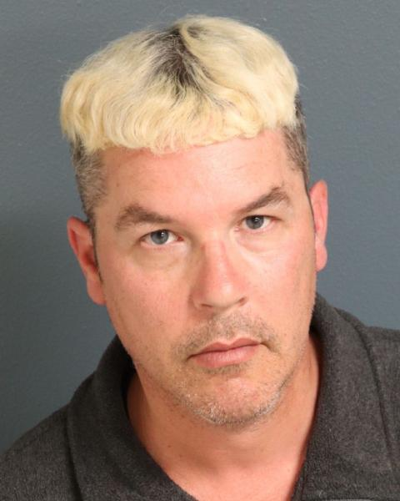

**Name: Rafford, Bruce Steven**

Race: White Sex: Male Age: 43 Height 5’06” Weight: 190lbs Hair: Brown Eyes: Blue Scars/Tattoos: Scar on Right wrist

**Offenses:**

**Child Molestation in the first degree, 1996**

**Child Molestation in the first degree, 1999**

In 1996, Rafford was convicted of Child Molestation 1st degree. In 1999, Rafford (age 18) was convicted of Child Molestation 1st degree. Rafford has participated in sex offender treatment. In 2004, Rafford was found to be a Sexually Violent Predator and civilly committed to the Special Commitment Center (SCC) on McNeil Island. In 2014, Rafford was found eligible for a Less Restrictive Alternative (LRA) placement and released from the SCC to reside at the Secure Community Transitional Facility (SCTF) on McNeil Island. In 2020, he was transferred to a LRA placement in the community. Rafford has been classified a Level 3 sex offender.  
  
*Sex offender laws allow for the tracking of offenders. The laws do not control the location of where and offender chooses to live or where they choose to obtain education.*

*In Washington state there are over 20,000 convicted sex offenders eligible for registration. There are currently over 2,600 registered sex offenders in Pierce County.*

**This information is meant to educate you about offenders in our community. It has not been made available for you to act against any individual. Please report all information on offenders directly to law enforcement. Those individuals seeking to harass, harm or confront an offender can be arrested and prosecuted. If you have a question, contact the Pierce County Sheriff’s Office at 253-798-7530**