# CHAPTER SECTION

|  |  |  |  |
| --- | --- | --- | --- |
| **TITLE**  **Travel** | **HISTORY** | | |
| **Adopted**  **2004** | **Campus Forum** | **Reviewed**  **2019** |
| **Revised**  **2018,2019** | **2019** | **Next review**  **2022** |

**3 3P**

# CLOVER PARK TECHNICAL COLLEGE PROCEDURE

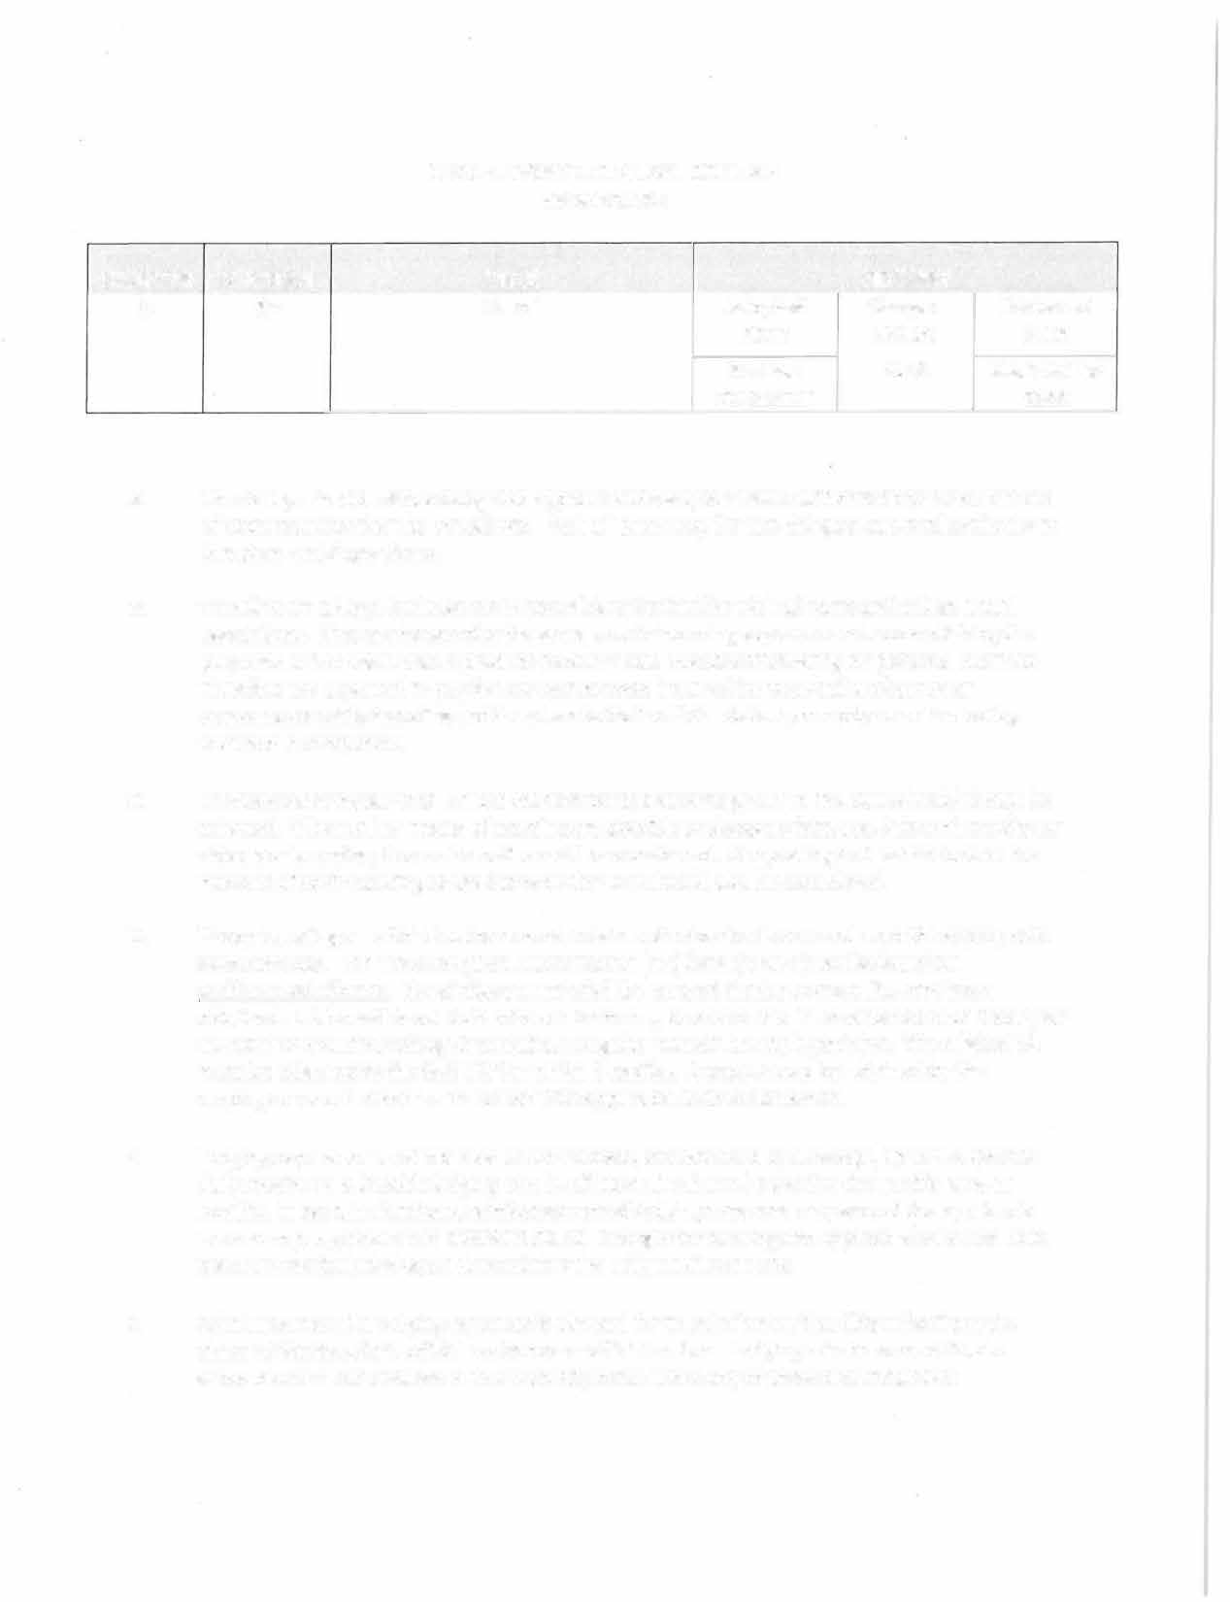

1. The College President has delegated approval authority for travel authorizations for all but out of state travel to the Vice Presidents. Each of these may further delegate approval authority to Directors and Supervisors.
2. Travelers on college business are responsible to be familiar with all state and college travel regulations. They are to exercise the same care in incurring expenses and accomplishing the purposes of the travel that a prudent person would exercise if traveling on personal business. Travelers are expected to pay for any excess costs incurred for personal preference or convenience while traveling and to return to their official station promptly when the college business is completed.
3. The travel alternative that is most economical and advantageous to the state should always be selected. When other means of meeting are possible and appropriate, e.g., teleconferencing or video conferencing, those alternatives will be considered. Car-pooling and restrictions on the number of staff traveling to the same destination should also be considered.
4. Those traveling on official business must obtain authorization in advance from the appropriate administrator. The Travel Request Authorization (TA) form should be submitted in CTCLink. . No reimbursement shall be assured if prior approval has not been obtained. A blanket Travel Authorization form may be completed in advance for each fiscal year to authorize routine travel (which includes mileage, meals, registration, parking, hotel, transportation, airfare) incurred as a regular part of the employee's job. Routine Travel does not include conferences organizezd by agencies outside of the SBCTC system or any out of state travel. Individual travel authorizations should be entered into CTCLink for this type of travel. An electronic copy of the approved blanket or individual TA must be attached to the TEV for which it applies.
5. Lodging expenses are reimbursed at actual costs, as evidenced by a receipt, up to the specific daily maximum allowable lodging rate in effect at the time of travel for the specific area or locality. In certain situations, reimbursement of lodging expenses may exceed the applicable maximum per guidelines in SAAM 10.30.20. Charges for parking and applicable sales and hotel taxes are not included when determining the daily maximum rate.
6. Reimbursement for lodging expenses is allowed for travel of more than fifty miles from the closer of the traveler's official residence or official station. Lodging reimbursement is also allowed when that distance is less than fifty miles under any of three circumstances:
   1. 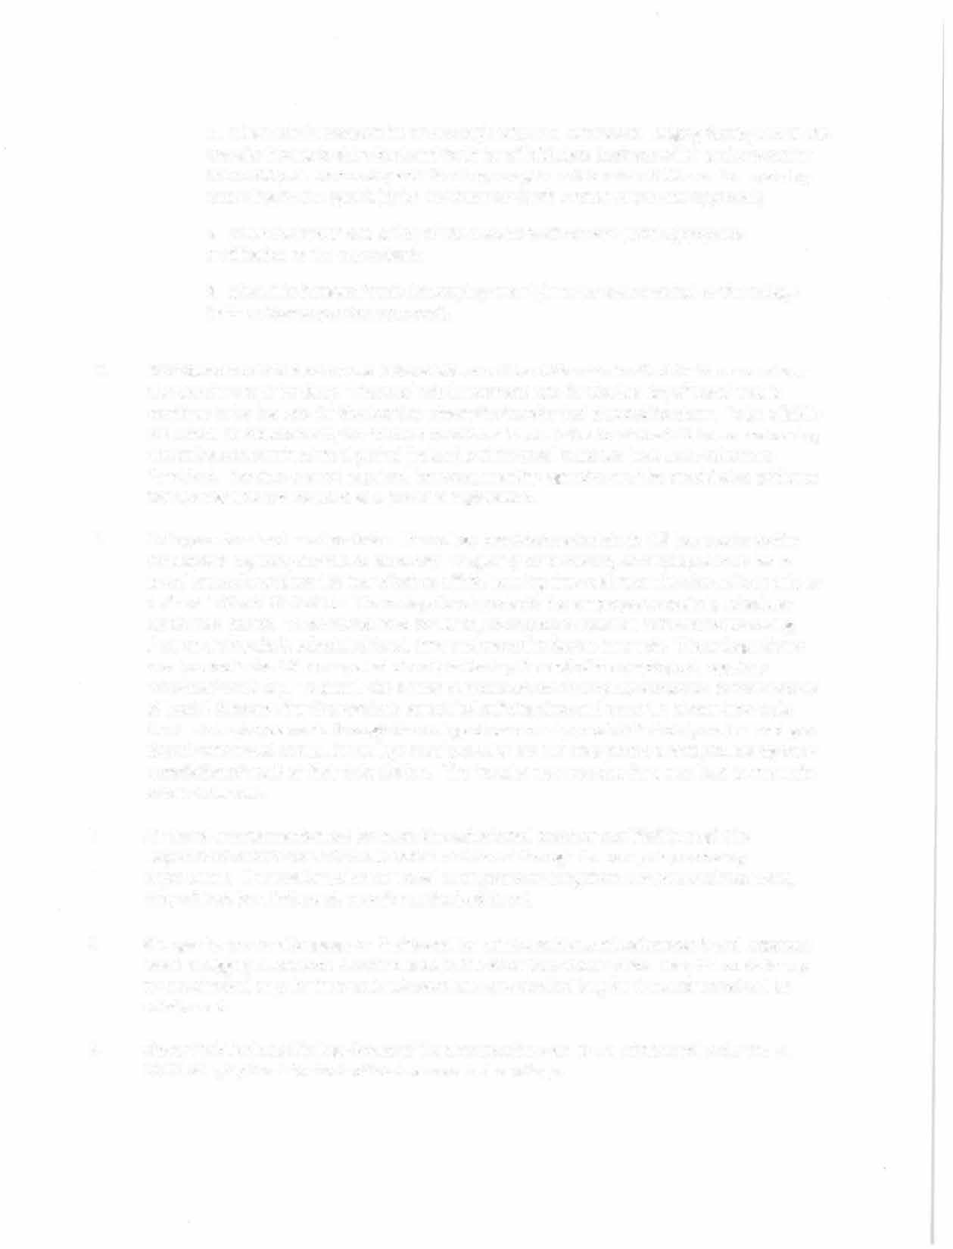when reimbursement for an overnight stay in a commercial lodging facility avoids the traveler having to drive back and forth for official state business which ends no earlier than 6:00 p.m. on one day and then begins again no later than 9:00 a.m. the next day, according to the agenda(s) for that business (with written supervisor approval);
   2. when the health and safety of the traveler is of concern (with appropriate notification to the supervisor);
   3. when it is demonstrated that staying overnight is more economical to the college (with written supervisor approval).
7. Reimbursement for meals while in travel status will be at the rate in effect for the area where the traveler stops for sleep. The meal reimbursement rate for the last day of travel would continue to be the rate for the location where the traveler last stopped for sleep. To be eligible for a meal reimbursement, the traveler must be in travel status for at least 11 hours and during the college-determined meal period (below) and the meal must not have been otherwise furnished. Receipts are not required, however, meeting agendas must be provided as evidence that a meal was not included as a part of a registration.
8. College-determined meal periods - The college breakfast period starts 1 ½ hours prior to the employee's regularly scheduled work day. To qualify for breakfast, an employee must be in travel status for at least 1 ½ hours before official starting time and meet the eleven-hour rule as defined in SAAM 10.40.50.b. The college lunch period is the employee's regularly scheduled lunch meal period. To be reimbursed for lunch, an employee must be in travel status during their entire regularly scheduled lunch time and meet the eleven-hour rule. The college dinner meal period is the 1 ½ hour period directly following the end of the employee's regularly scheduled work day. To qualify for dinner reimbursement an employee must be in travel status at least 1 ½ hours after the regularly scheduled quitting time and meet the eleven-hour rule. When an employee works through the college dinner meal period at their duty station and goes directly into travel status, the college meal period is the 1 ½ hour period directly following their completion of work at their duty station. The traveler may not stop for a meal just to meet the eleven-hour rule.
9. Air travel arrangements must be made through a travel provider qualified through the Department of Enterprise Services and administered through the college's purchasing department. If a traveler makes air travel arrangements using their own personal resources, they will not be reimbursed, even for authorized travel.
10. Charges for personal baggage on flights shall be reimbursable as miscellaneous travel expenses when a baggage allowance is not included in the state travel ticket price. Only the costs for up to two checked bags for international travel and one checked bag for domestic travel will be reimbursed.
11. Clover Park Technical College Board of Trustees members are to be reimbursed under SAAM 10.70.30.b, Option 1 for their official services to the college.
12. 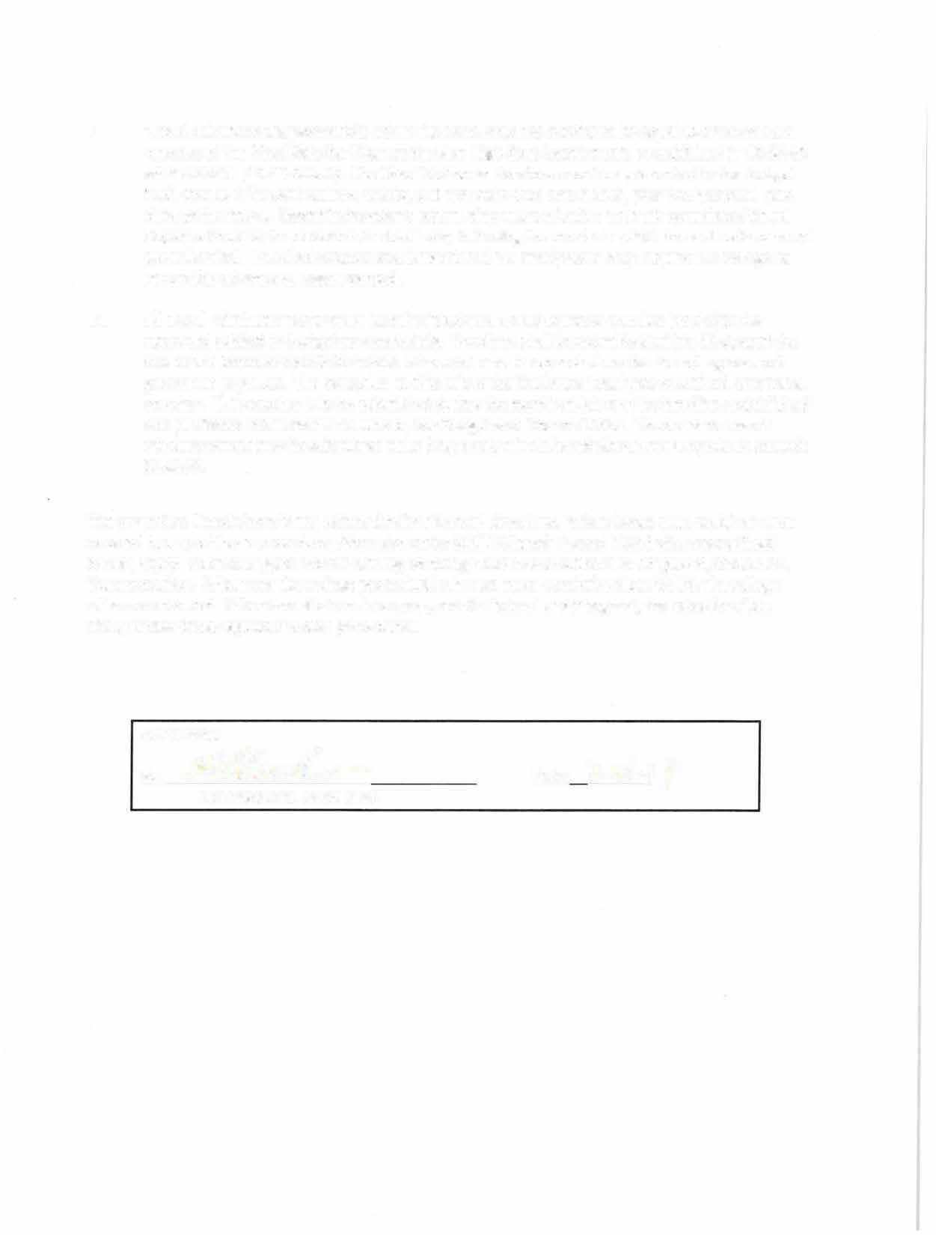 Travel Advances are permissible when the travel advance itself is to be equal to or more than one day of the Meal Rate Per Diem at the Non High-Cost Location rate as published in 10.90.20 of the SAAM. (10.80.60.b.7). The Travel Authorization form must be presented to the Budget and Finance Office at least two weeks, but not more than one month, prior to the actual start date of the travel. Upon the traveler's return, they must submit a properly completed Travel Expense Voucher on or before the tenth day following the month in which the authorized travel period ended. Travel advances not substantiated in a timely basis may require the college to report the advance as wages earned.
13. All travel reimbursements must be submitted on a Travel Expense Voucher (A20-A) to be approved subject to budgetary constraints. Vouchers shall be submitted within 30 days of the end of the calendar month for which reimbursement is requested or else the college cannot guarantee payment. The exception to this rule is the final state fiscal year month of June travel voucher. This voucher is to be submitted during the month of July per the timelines established and published in the month of June by the Budget and Finance Office. Vouchers for travel reimbursement may be submitted more frequently when the reimbursement equals or exceeds

$150.00.

The procedure listed above is not exhaustive for all travel situations. When issues arise which are not covered by any of these procedures, the rules under SAAM Chapter 10 and FLSA (rules are outlined below) apply. Additional guidance for driving on college business is outlined in Chapter 6, Section 25, Transportation. Whenever the college procedural rules are more restrictive than SAAM, the college rules are enforced. When travel takes place as a part of a federal or state grant, the rules for allow ability under those regulations take precedence.

APPROVAL:

**By:;4** Date: ?- **/6-/** *7*

Vice President Name Here

**Non-Exempt Employees FLSA Travel Pay Chart**

## Travel Cate#ory Compensable Time

**Commuting** •Performing authorized work-related errands

while commuting from home to work or from work to home.

•Transporting or delivering materials or equipment to a job site prior to the start of the work day and/or returning materials or equipment after the end of the work day

**Travel During** •Time spent in travel as part ofthe employee's **Normal Work** principal job activity (i.e., travel between job **Hours** sites).

**Same Day** •Time spent traveling to and returning from a **Assignment Away** one-day required assignment in another city or **From Duty** town regardless ofwhether employee is the **Station** driver or the passenger, regardless of whether

the travel cuts across the normal work schedule.

•Time spent at required conference, meeting, etc.

**Overnight Travel** •Any portion ofauthorized travel, including

time spent waiting at an airport, bus station, etc., that cuts across an employee's normal work schedule, including non-work days.

•lfan employee travels between two or more time zones, the time zone associated with the point of departure determines whether the travel falls within normal work hours.

•Riding as a passenger when the employee is required to perform work (for example, to serve as an assistant or helper, respond to email, take business-related phone calls, etc.).

•Driving a vehicle, regardless ofwhether the travel takes place within or outside normal work hours.

•Time spent attending authorized conferences, meetings, etc.

•Required attendance at meals or meal breaks where work is perfonned.

•Required attendance at social functions.

## Non-comoensable Time

•Ordinary travel from home to work (commuting time) †

•Normal commuting time will be subtracted.

•Time not worked even ifit cuts across the employee's regular work schedule (e.g., employee goes sightseeing instead ofattending a conference session, the conference sessions are only from 9a.m. to 3 p.m., etc.).

•Meal periods and social activities where attendance is not required and work is not performed.

•Any portion ofauthorized travel, including time spent waiting at an airport, bus station, etc., that falls outside of normal work hours.

•Riding as a passenger outside ofnonnal work hours where work is not required.

•Travel between hotel and meeting site.

•Ifan employee drives a car as a matter ofpersonal preference when an authorized flight or other travel mode is available and paying for travel by car would exceed the cost ofthe authorized mode, only the estimated travel time associated with the authorized mode will be counted as hours worked

•Ifthe employer authorizes hotel accommodations for overnight travel but the employee prefers to drive home each evening.

•Regular meal periods where work is not performed and attendance is not required.

•Voluntary attendance at social functions.

•Time spent outside of the conference or

meeting (e.g., employee goes sightseeing instead of attending a conference session, the conference sessions are only from 9a.m. to 3 p.m., etc.).

•Time spent sleeping unless the employee has the primary

resoonsibilitv for the safety and welfare of students.

