

**How to Schedule appointment with your Program Counselor/Advisor in Navigate**

**Navigate For CPTC Students:** *Navigate is a tool that students use to make appointments and located campus resources*.

**Step 1: Go to Navigate.**

* Navigate can be accessed using the **Navigate Student** app
* -Or from the direct CPTC Navigate web site [**https://cptc.navigate.eab.com/**](https://cptc.navigate.eab.com/)

(Use Chrome or Firefox browser for best results)

* -Or from the main CPTC website Go to [www.cptc.edu](http://www.cptc.edu) then

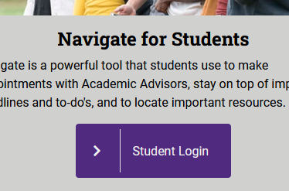**→** click on **MyCC (ctcLink) →** Click on the **Navigate** Tile **→** then click **Student Login**

**1**

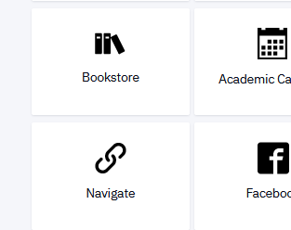

**2**

**3**

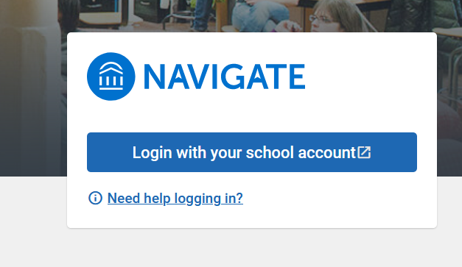

**Step 2: Log in using the same information you use for your Canvas Login**

Click on the “Navigate for Students” Icon. Accept conditions.

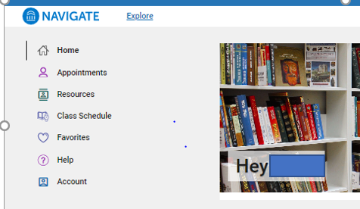 **Student Dashboard View**

* “Home” screen where you will see welcoming & date.
* “Appointments” will display any planned appointments and is where you can schedule an appointment.
* “Resources” will display resources available at CPTC.
* “Class Schedule” will display current term classes.
* “Account” will display name & ctcLink ID & email address.

*Continue on next page*

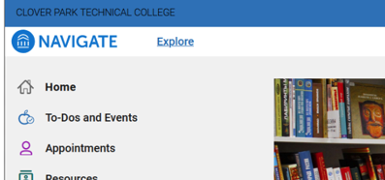

**Step 3: Click on Appointments Tab**

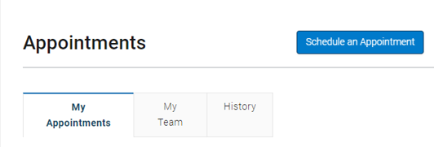

**Step 4: Click the Blue button “Schedule an Appointment”**

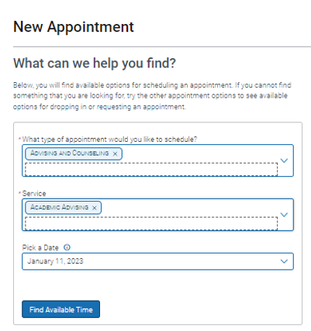

**Step 5: Select “New Appointment” a window will open**

Click the Blue button “Schedule or Drop In for an Appointment”  
The following will open:  
- Choose What type of appointment would you like to schedule: “**Advising and Counseling”**  
- Then choose the “**Service**”.  
- Then Pick a Date and click on “**Find a available time**”

**Step 6: Select a date and time**

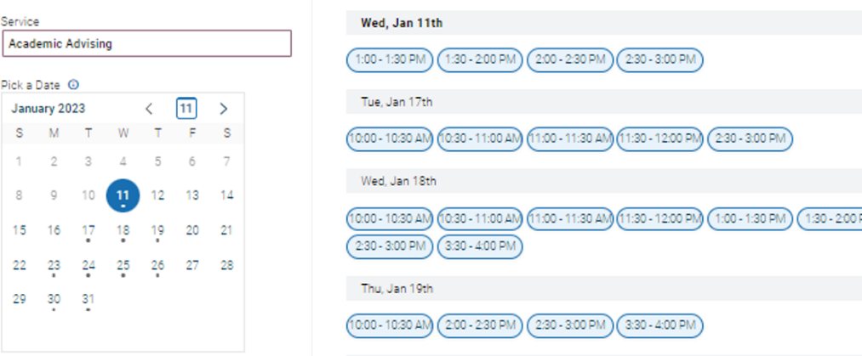

*Continue on next page*

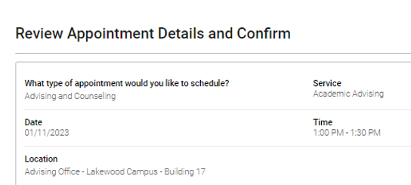

**Step 7: ­­­ Complete the Select form**

* **Select how you like to meet (phone, online, in-person)**
* **Enter phone number for text reminder**
* **Click the blue “Submit” button**

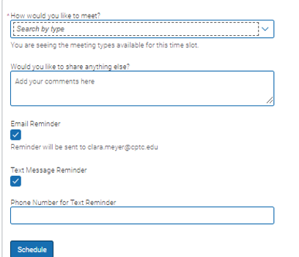



**You will then see this screen confirming your appointment was scheduled.**

**Navigate Help**

**Trouble Logging in?**

* Contact Gordon Walters for help resolving your issues. [Brandon.burks@cptc.edu](mailto:Brandon.burks@cptc.edu)
* You are unable to use Navigate you can call the main Advising & Counseling number to speak with a staff person to schedule an advising appointment: **253-589-5548**